Lab - 1: Introduction to MATLAB
EXERCISES
1. Use the subplot command to provide the following three plots in one figure:
- Plot 1: sin(t), sin(3t), sin(5t)
- Plot 2: cos(t), cos(3t), cos(5t)
- Plot 3: tan(t), tan(3t), tan(5t)
For. It is important to use different color schemes to differentiate the harmonics; provide legend, xlabel, ylabel, and title for each plot.

MATLAB Code
% Time vector from -2*pi to 2*pi
t = linspace(-2*pi, 2*pi, 1000); % Create a time vector t with 1000 points between -2*pi and 2*pi

% Define the functions
sin_t = sin(t); % Sine function sin(t)
sin_3t = sin(3*t); % Sine function sin(3t), which represents the third harmonic
sin_5t = sin(5*t); % Sine function sin(5t), which represents the fifth harmonic

cos_t = cos(t); % Cosine function cos(t)
cos_3t = cos(3*t); % Cosine function cos(3t), third harmonic of cosine
cos_5t = cos(5*t); % Cosine function cos(5t), fifth harmonic of cosine

tan_t = tan(t); % Tangent function tan(t)
tan_3t = tan(3*t); % Tangent function tan(3t), third harmonic of tangent
tan_5t = tan(5*t); % Tangent function tan(5t), fifth harmonic of tangent

% Create a figure with 3 subplots
figure; % Create a new figure window for plotting

% Plot 1: Sine functions
subplot(3,1,1); % Divide the figure into a 3-row, 1-column grid; this is the first subplot
plot(t, sin_t, 'b', 'DisplayName', 'sin(t)'); % Plot sin(t) in blue
hold on; % Keep the current plot so that other functions can be plotted on the same axes
plot(t, sin_3t, 'g', 'DisplayName', 'sin(3t)'); % Plot sin(3t) in green
plot(t, sin_5t, 'r', 'DisplayName', 'sin(5t)'); % Plot sin(5t) in red
hold off; % Release the hold to prevent further plotting on this axes
title('Sine Functions'); % Title of the first plot
xlabel('t'); % Label for the x-axis
ylabel('Amplitude'); % Label for the y-axis
legend; % Display the legend for the different sine functions

% Plot 2: Cosine functions
subplot(3,1,2); % Second subplot in the 3-row, 1-column grid
plot(t, cos_t, 'b', 'DisplayName', 'cos(t)'); % Plot cos(t) in blue
hold on; % Keep the current plot to add more plots on the same axes
plot(t, cos_3t, 'g', 'DisplayName', 'cos(3t)'); % Plot cos(3t) in green
plot(t, cos_5t, 'r', 'DisplayName', 'cos(5t)'); % Plot cos(5t) in red
hold off; % Release the hold to stop further plotting on this axes
title('Cosine Functions'); % Title of the second plot
xlabel('t'); % Label for the x-axis
ylabel('Amplitude'); % Label for the y-axis
legend; % Display the legend for the cosine functions

% Plot 3: Tangent functions with limits
subplot(3,1,3); % Third subplot in the 3-row, 1-column grid
plot(t, tan_t, 'b', 'DisplayName', 'tan(t)'); % Plot tan(t) in blue
hold on; % Keep the current plot to add other tangent harmonics
plot(t, tan_3t, 'g', 'DisplayName', 'tan(3t)'); % Plot tan(3t) in green
plot(t, tan_5t, 'r', 'DisplayName', 'tan(5t)'); % Plot tan(5t) in red
%hold off; % This hold is commented out, but can be used to stop plotting on this axes
ylim([-10 10]); % Limit the y-axis to the range [-10, 10] to avoid asymptotes in the tangent plot
title('Tangent Functions'); % Title of the third plot
xlabel('t'); % Label for the x-axis
ylabel('Amplitude'); % Label for the y-axis
legend; % Display the legend for the tangent functions
% Adjust layout
sgtitle('Harmonics of Sine, Cosine, and Tangent'); % Super-title for the entire figure, combining all three subplots

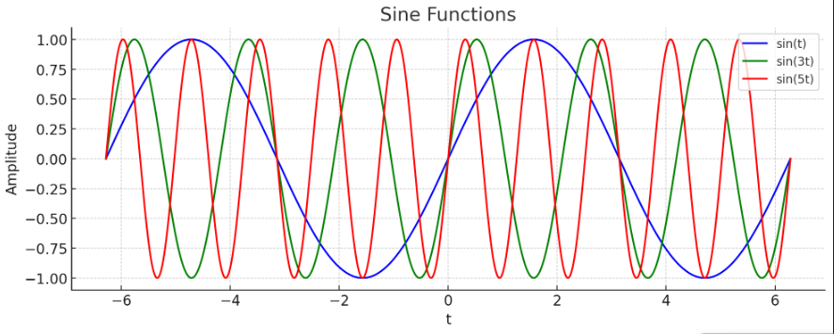
Output Plot
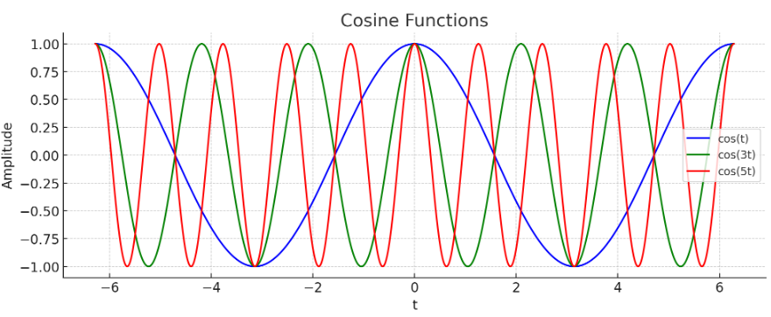
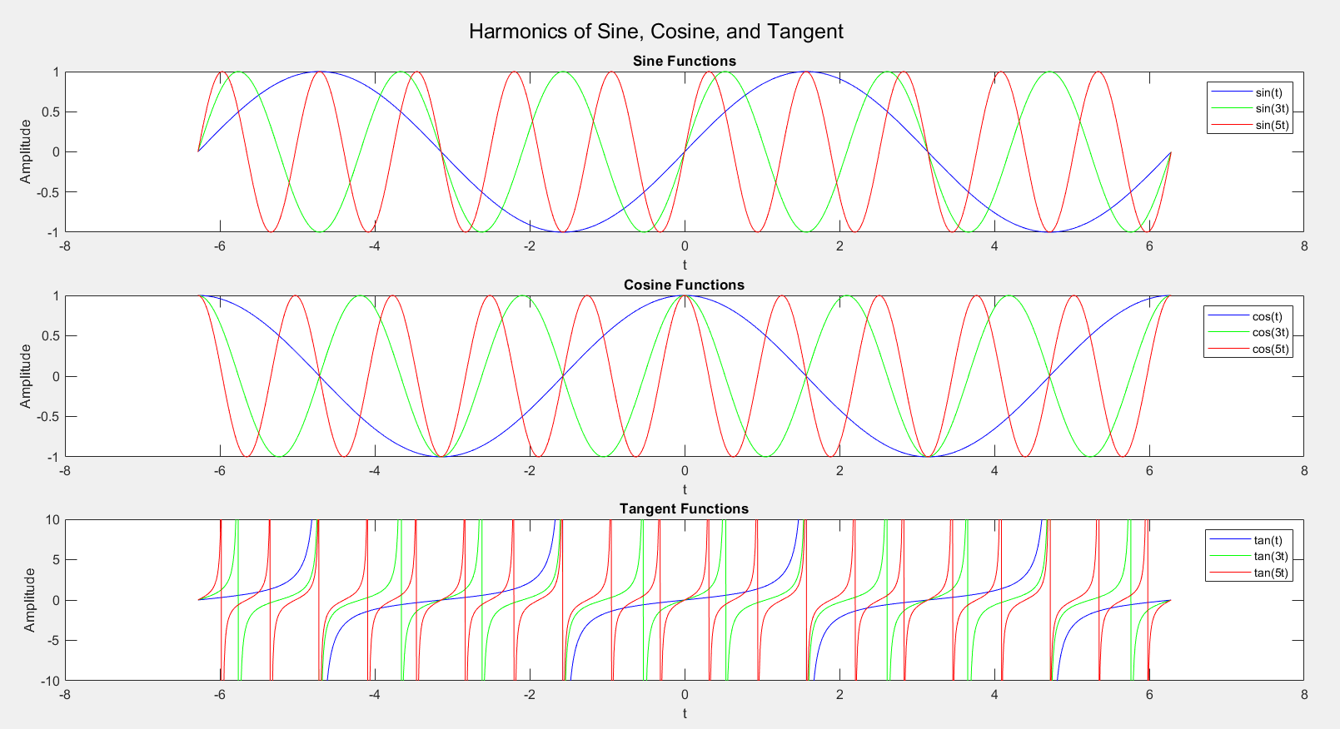
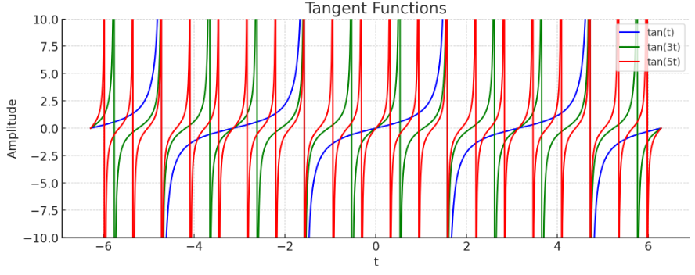

2.Write a MATLAB function, which takes the following two inputs:
- A vector (of variable length) representing resistors in an electrical circuit
- A flag representing whether resistors are in parallel or series
The function should return equivalent resistance.

MATLAB Code
Function
function Req = equivalent_resistance(resistors, config)
% equivalent_resistance - Calculates and displays the equivalent resistance
% Inputs:
% resistors - a vector of resistor values
% config - a string ('series' or 'parallel') indicating the configuration
% Output:
% Req - the equivalent resistance
% Check if resistors input is valid
if isempty(resistors)
error('Resistors vector cannot be empty.');
end
% Check if config is valid
if ~ischar(config) || (~strcmpi(config, 'series') && ~strcmpi(config, 'parallel'))
error('Configuration must be either ''series'' or ''parallel''.');
end
% Calculate equivalent resistance based on the configuration
if strcmpi(config, 'series')
% Sum resistances for series configuration
Req = sum(resistors);
disp(['Equivalent resistance in series: ', num2str(Req), ' ohms']);
elseif strcmpi(config, 'parallel')
% Sum reciprocals for parallel configuration
Req = 1 / sum(1 ./ resistors);
disp(['Equivalent resistance in parallel: ', num2str(Req), ' ohms']);
end
end
Calling the Function
R = [10, 20, 30]; % Vector of resistor values
Req_series = equivalent_resistance(R, 'series'); % Equivalent resistance in series
Req_parallel = equivalent_resistance(R, 'parallel'); % Equivalent resistance in parallel

Result
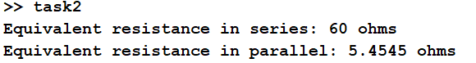
3. Define the symbolic variable x. Make use of this variable to define the symbolic function sin(1/x). Then, plot the function from 0 to 2. What do you see? Why might the plotting routine be having trouble plotting this function?

MATLAB Code
% Define the symbolic variable
syms x
% Define the symbolic function
f = sin(1/x);
% Plot the function from 0 to 2
fplot(f, [0.01, 2]) % Avoid 0 due to singularity
% Add labels and title
xlabel('x')
ylabel('sin(1/x)')
title('Plot of sin(1/x) from 0 to 2')
grid on

Plot:
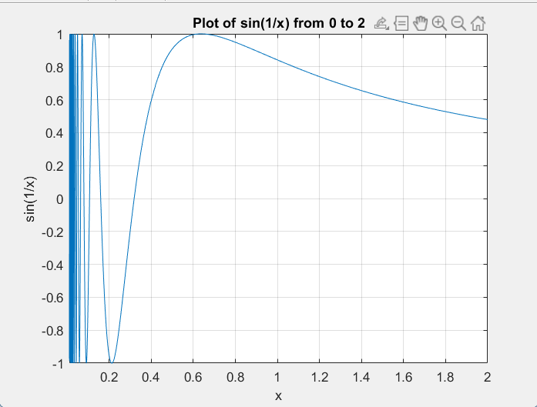

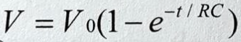
4. The natural response of a series RC circuit is given by

Write a MATLAB function that takes two inputs R and C, and plots the natural response of this circuit for
MATLAB Code

Function:
function plot_RC_response(R, C)
% plot_RC_response - Plots the natural response of a series RC circuit
% Inputs:
% R - Resistance in ohms
% C - Capacitance in farads
% This function plots the voltage decay v(t) = V0 * exp(-t / (R * C))
% Define time vector from 0 to 2 seconds
t = linspace(0, 2, 1000); % 1000 points for smooth plotting
% Initial voltage (assuming V0 = 1 volt for simplicity)
V0 = 1;
% Natural response of the RC circuit
v_t = V0 * exp(-t / (R * C));
% Plot the natural response
plot(t, v_t, 'LineWidth', 2)
xlabel('Time (s)')
ylabel('Voltage v(t) (V)')
title(['Natural Response of RC Circuit (R = ' num2str(R) ', C = ' num2str(C) ')'])
grid on
end

Calling the Function:
% Example with R = 100 ohms and C = 0.01 farads
plot_RC_response(100, 0.01)

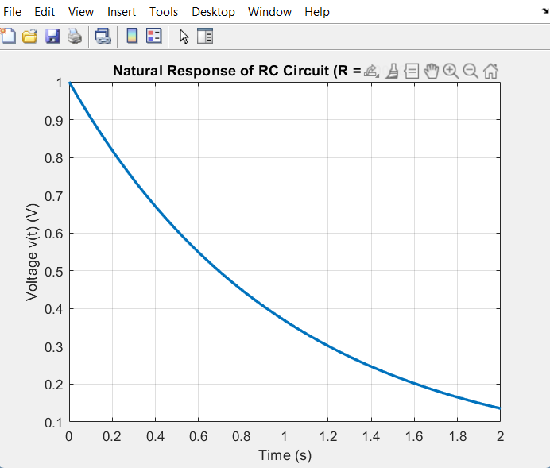
Plot:

